Uploading EDU 690 Projects to the Digital Commons

Step One: Click the link below to visit the IGPE project page and select Submit Your Work
https://digitalcommons.buffalostate.edu/igpe_project/

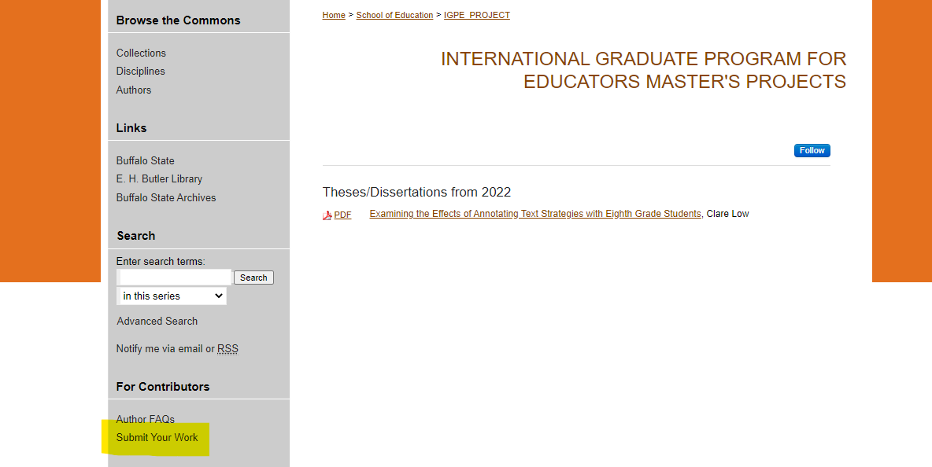

Step Two: Select create your account and create an account. The password must be at least 8 characters, including at least 1 upper case letter, 1 lower case letter, 1 number, and 1 special character. An email will be sent to confirm your account.
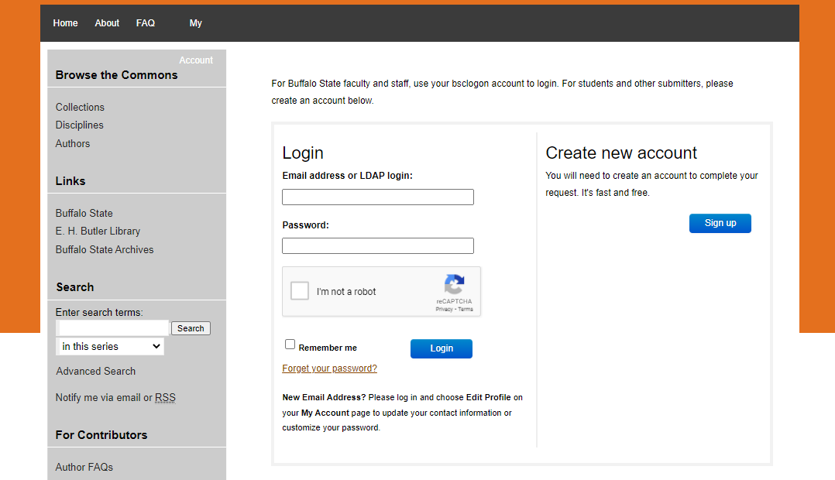
Step Three: Click link in email and login
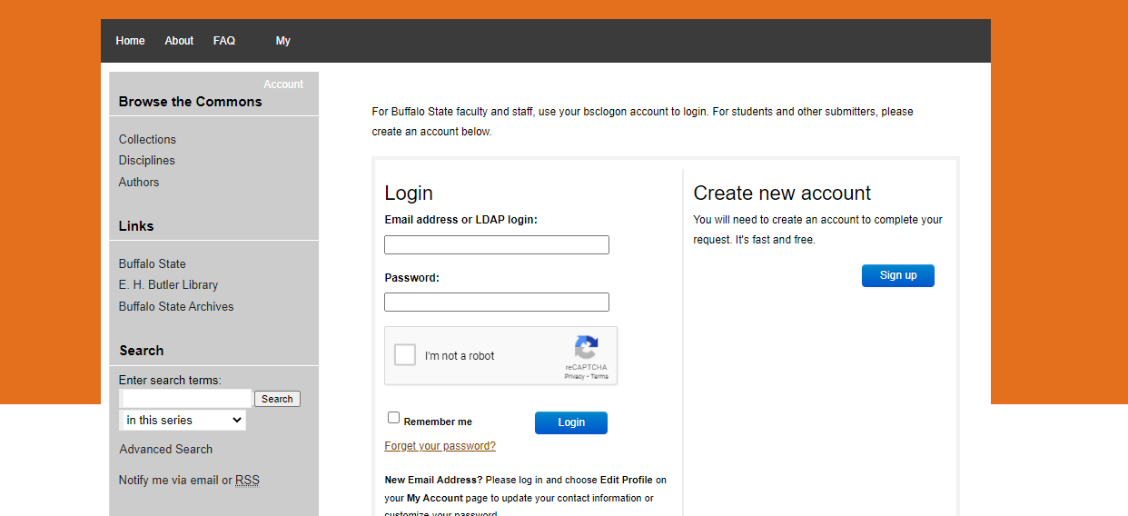

Step 4: Select Agree to the terms after review
Step 5: Complete the form accordingly. It is only required to complete the required sections- in red, yet you may choose to complete others as appropriate
Title- Title of your project
Author- Your email/name will be selected automatically
Date of Award- Month and year that you graduated from SUNY Buffalo State
Embargo Period- No Embargo Required
Access Control- Open Access
Degree Name: International Graduate Program for Educators- MS in Multidisciplinary Studies
Department: International Graduate Program for Educators
Upload Full Text: Upload the document

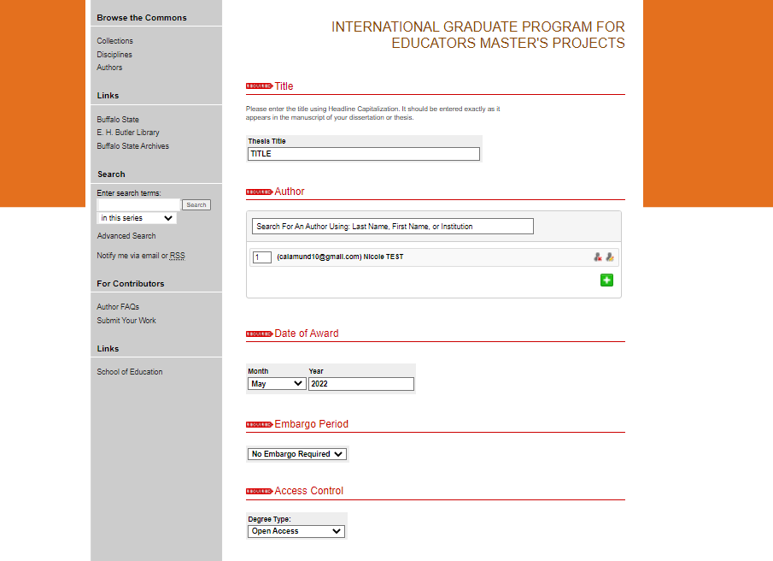

Step 6: Click on Submit to finalize
When your submission has been reviewed and accepted, you will receive an update via email. You may get an email asking for corrections or a resubmission. Follow the directions in that email and resubmit if needed.
Please note, by default all submission to Digital Commons are open to the public to download and view.
If you have problems or need assistance, please contact Nicole Calamunci, calamund@buffalostate.edu

